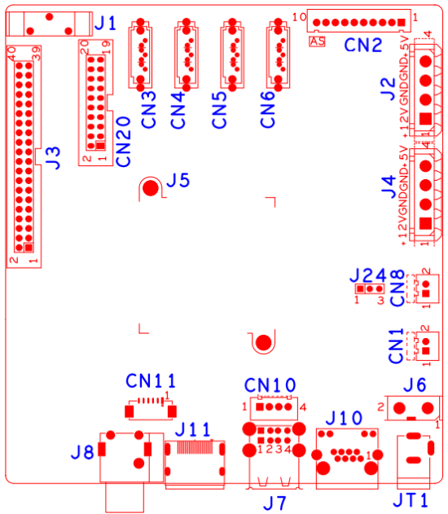
代号 | 功能描述 | 接口定义
CN1 | 风扇电源座子 | 1：+12 | 2：GND
CN8 | 风扇电源座子 | 1：+12 | 2：GND
CN3 | SATA接口
CN4 | SATA接口
CN5 | SATA接口
CN6 | SATA接口
CN10 | USB扩展座子
CN2 | 带单片机前面板扩展接口 | 1：+5V | 2：GND | 3：+5_STB | 4:GND
 |  | 5:NC | 6:NC | 7:RXD_FRONT | 8:TXD_FRONT
 |  | 9:PWR_S | 10:GND
J2 | 硬盘电源座子 | 1：+12 | 2：GND | 3:GND | 4:+5
J4 | 硬盘电源座子 | 1：+12 | 2：GND | 3:GND | 4:+5
J6 | 12V电源开关
JT1 | 12V电源输入接口
J24 | RS232接口
J7 | USB2.0接口
CN11 | VGA扩展座子
J11 | HDMI接口
J10 | 网口
J8 | 音频输入输出接口 | 上：AUDIO_LINE_IN1 | 下：AUDIO_OUT_MAIN
J5 | 散热片
J1 | 电池座子
CN20 | 报警输入输出扩展座子 | 1:NC | 2:5V | 3:GND | 4:5V
 |  | 5:NC | 6:5V | 7:NC | 8:NC
 |  | 9:GND | 10:GND | 11:NC | 12:NC
 |  | 13:NC | 14:NC | 15:NC | 16:ALARM_IN1
 |  | 17:ALARM_IN4 | 18:ALARM_IN2 | 19:ALOUT1 | 20:ALARM_IN3
J3 | 报警输入输出、RS232、RS485扩展座子 | 1：NC | 2:NC | 3:NC | 4:GND
 |  | 5:NC | 6:NC | 7:GND | 8:NC
 |  | 9:NC | 10:GND | 11:NC | 12:NC
 |  | 13:GND | 14:ALOUT4 | 15:ALOUT2 | 16:GND
 |  | 17:ALOUT3 | 18:ALARMIN_16 | 19:GND | 20:RS232_R
 |  | 21:RS232_T | 22:GND | 23:RS485_B | 24:RS485_A
 |  | 25:GND | 26:ALARM_IN10 | 27:ALARM_IN9 | 28:ALARM_IN11
 |  | 29:ALARM_IN8 | 30:ALARM_IN12 | 31:GND | 32:GND
 |  | 33:ALARM_IN5 | 34:ALARM_IN13 | 35:ALARM_IN6 | 36:ALARM_IN14
 |  | 37:ALARM_IN7 | 38:ALARM_IN15 | 39:GND | 40:GND

本接口说明对应产品型号：NBD8032H4-UL

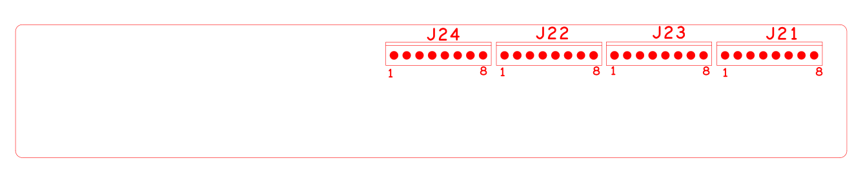 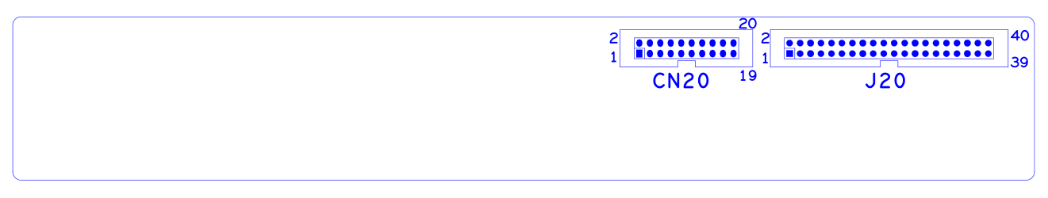 代号功能描述接口定义J24报警接口1:ALARM_IN162:GND3:ALARMOUT3_C4:ALARMOUT3_NO5:ALARMOUT4_C6:ALARMOUT4_NO7:RS485_A8:RS485_BJ22报警接口1:ALARM_IN92:ALARM_IN103:ALARM_IN114:ALARM_IN125:GND6:ALARM_IN137:ALARM_IN148:ALARM_IN15J23报警接口1:ALARM_IN82:GND3:ALARMOUT1_C4:ALARMOUT1_NO5:ALARMOUT2_C6:ALARMOUT2_NO7:RS232_R8:RS232_TJ21报警接口1:ALARM_IN12:ALARM_IN23:ALARM_IN34:ALARM_IN45:GND6:ALARM_IN57:ALARM_IN68:ALARM_IN7J20报警输入输出、RS232、RS485扩展座子1:NC2:NC3:NC4:GND5:NC6:NC7:GND8:NC9:NC10:GND11:NC12:NC13:GND14:ALOUT415:ALOUT216:GND17:ALOUT318:ALARMIN_1619:GND20:RS232_R21:RS232_T22:GND23:RS485_B24:RS485_A25:GND26:ALARM_IN1027:ALARM_IN928:ALARM_IN1129:ALARM_IN830:ALARM_IN1231:GND32:GND33:ALARM_IN534:ALARM_IN1335:ALARM_IN636:ALARM_IN1437:ALARM_IN738:ALARM_IN1539:GND40:GNDCN20报警输入输出扩展座子1:NC2:5V3:GND4:5V5:NC6:5V7:NC8:NC9:GND10:GND11:NC12:NC13:NC14:NC15:NC16:ALARM_IN117:ALARM_IN418:ALARM_IN219:ALOUT120:ALARM_IN3 本接口说明对应产品型号:F系列16路报警接口板-NVR专用

