KA18EV-S1-38X38-IM-WIFI-V2_01接口说明表

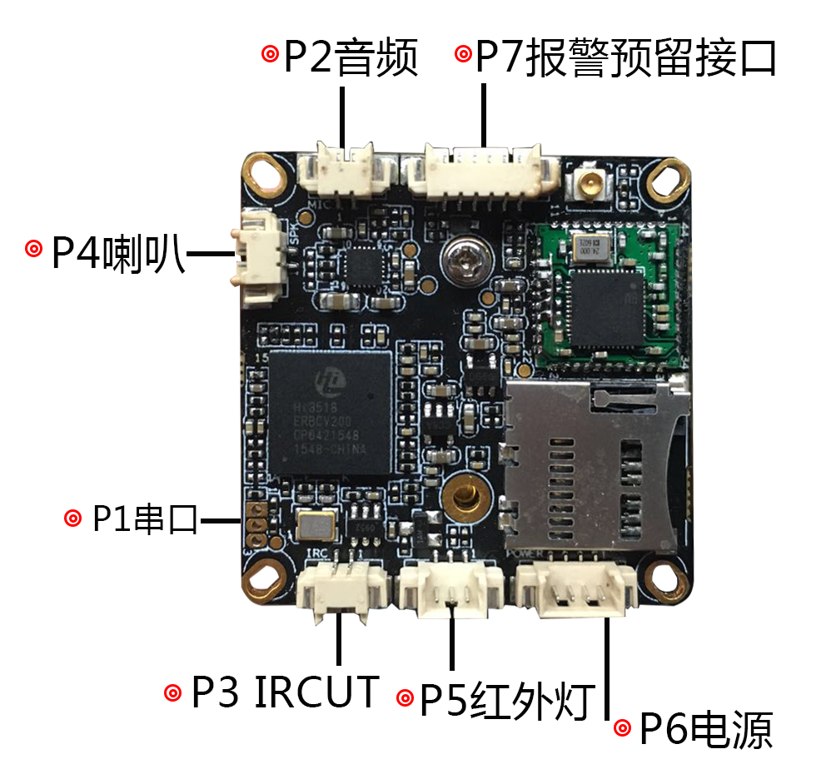

|  |  |  |  |  |
| --- | --- | --- | --- | --- |
| 标注 | 丝印编号 | 针脚编号 | 针脚定义 | 功能 |
| P1 | J3 | 1 | Uart_RXD | 串口接收 |
| 2 | Uart_TXD | 串口发送 |
| 3 | GND | GND |
| P2 | J9 | 1 | MIC_P | 音频输入 |
| 2 | GND | 地 |
| P3 | J1 | 1 | OUT1 | IRCUT驱动输出 |
| 2 | OUT2 | IRCUT驱动输出 |
| P4 | J8 | 1 | 喇叭 | 喇叭 |
| 2 | 喇叭 | 喇叭 |
| P5 | J4 | 1 | 红外输入 | 红外输入 |
| 2 | GND | GND |
| 3 | NC | 悬空 |
| P6 | J5 | 1 | NC | 悬空 |
| 2 | NC | 悬空 |
| 3 | GND | GND |
| 4 | +12V | 12V电源输入 |
| P7 | J11 | 1 | 3.3V | 3.3V |
| 2 | GND | GND |
| 3 | ALARM_IN | 报警/复位 |
| 4 | GPIO63 |  |
| 5 | GPIO01 |  |
| 6 | GPIO02 |  |
| P8 | J7 | 1 | DATA0 | 数据口0 |
| 2 | DATA1 | 数据口1 |
| 3 | DATA2 | 数据口2 |
| 4 | DATA3 | 数据口3 |
| 5 | DATA4 | 数据口4 |
| 6 | DATA5 | 数据口5 |
| 7 | DATA6 | 数据口6 |
| 8 | DATA7 | 数据口7 |
| 9 | DATA8 | 数据口8 |
| 10 | DATA9 | 数据口9 |
| 11 | DATA10 | 数据口10 |
| 12 | DATA11 | 数据口11 |
| 13 | GND | GND |
| 14 | GND | GND |
| 15 | PCLK | 像素时钟 |
| 16 | SENSOR_CLK | SENSOR主时钟 |
| 17 | HS | 行同步 |
| 18 | VS | 场同步 |
| 19 | SCL | I2c时钟 |
| 20 | SDA | I2c数据 |
| 21 | DVDD | DVDD |
| 22 | GND | GND |
| 23 | DOVDD | DOVDD |
| 24 | AVDD | AVDD |