**IPG-50H10PE-WK,IPG-53H13PE-WK模组接口定义**

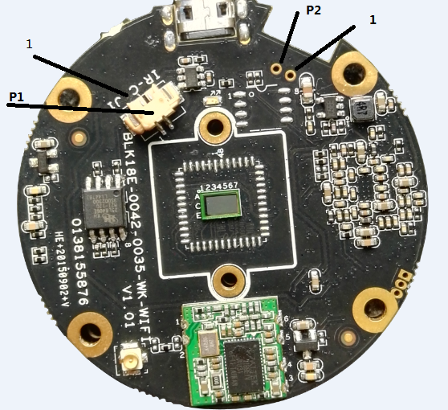

P5

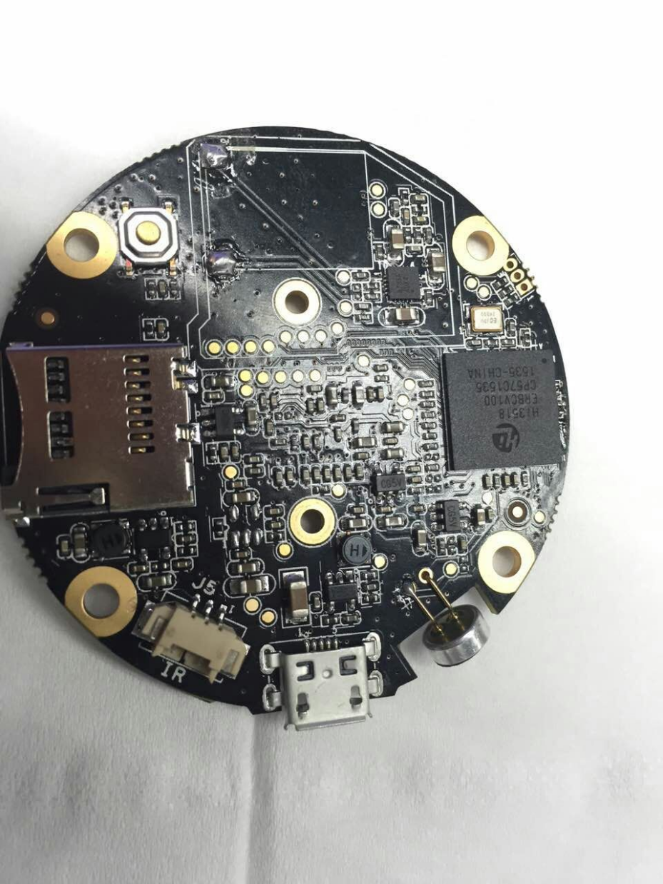

p4

1

p3

|  |  |  |  |  |
| --- | --- | --- | --- | --- |
| 标注 | 丝印编号 | 针脚编号 | 针脚定义 | 功能 |
| P1 | J1 | 1 | Ircut1 | Ircut控制端 |
| 2 | Ircut2 | Ircut控制端 |
| P2 |  | 1 | GND | 地 |
| 2 | AI | Mic输入端 |
| P3 |  | 1 | AO1 | 喇叭 |
| 2 | AO2 | 喇叭 |
| P4 | J5 | 1 | GND | 地 |
| 2 | IR_DIED | 红外灯输入端 |
| 3 | 5V | 输出5V电源 |
| P5 | U1 | 1 | RF-GND | 天线地 |
| 2 | ANT | 天线 |
| 3 | 3.3V | 3.3V |
| 4 | USB_DM | USB数据正信号 |
| 5 | USB_DP | USB数据负信号 |
| 6 | GND | 地 |