XM-JPN1-RW

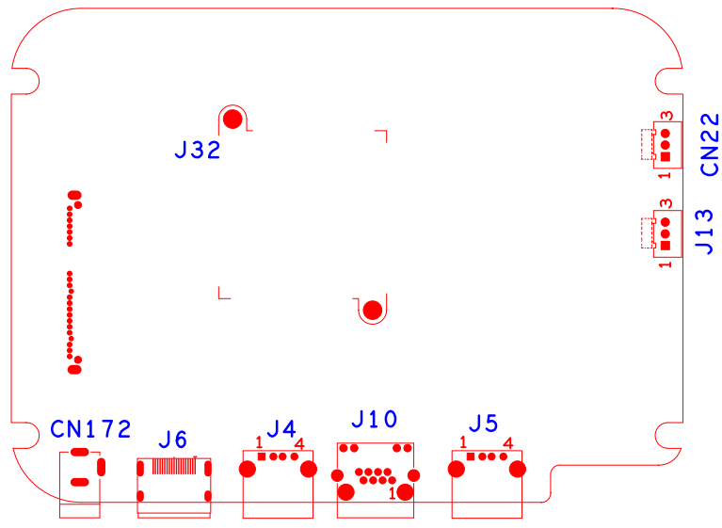

|  |  |  |  |  |  |
| --- | --- | --- | --- | --- | --- |
| 位号 | 功能描述 | 接口定义 | | | |
| CN172 | 12V输入电源接口 |  |  |  |  |
| J13 | XM722调试接口 | 1:RXD | 2:TXD | 3:GND |  |
| CN22 | 主控调试接口 | 1：UART0_RXD | 2:UART0_TXD | 3:GND |  |
| J4 | USB接口 |  |  |  |  |
| J5 | USB接口 |  |  |  |  |
| J10 | RJ45座子 |  |  |  |  |
| CN1 | 22芯SATA母座 |  |  |  |  |
| J6 | HDMI接口 |  |  |  |  |